Debre Berhan University

College of Computing

Department of Computer Science

Course: CoSc4181 - Selected Topics in Computer Science

Assessment 1: App Development using OOP paradigm

|  |
| --- |
| Submitted to- Instructor Chalew T.  Submission date- May 2022 |

Group: one (1)

**Name**   **ID**

1. Chernet Tebebu DBUR/1777/11
2. Emebet Belayneh DBUR/1685/11
3. Raey Habtamu DBUR/1872/11
4. Balemlay Tegbar DBUR/1132/10
5. Znash Wulatew DBUR/1804/11
6. Endaweke Enyew DBUR/1179/10
7. **Introduction**

Broker is the person who makes a contact between seller/renter and buyer, and then post the service information through the application. Web based broker management system is the process whereby customers buy, rent and sell goods or services and also search for guards and house servants through online in real-time, over the Internet. We are highly motivated to change this manual system in to computerized web based system to increase the quality of the service, decrease workload, man power, and cost and store the data in the database to change the current paper based data record process.

1. **Objective**

The objective of this project is to design and implement a web based broker service system.

1. **Existing System**
   1. **Overview**

The current system has the following problems:

* Lack of multiple options: It is difficult to pick between numerous demands such as a home, vehicles, and employment. Customers are unable to make their own decisions due to a lack of information regarding their needs.
* Low customer satisfaction: Serving clients in a short amount of time is challenging, therefore customers feel fatigued and bored.
* Lack of accessibility: The office is situated at the particular location, so the number of client cannot able to come from far locations. Only the people who are near to the office can register for sell rent or buy service.
* Wastage of time: Performing individual activities takes a long time. Finding the right property for you and your family can be a difficult task. The service is slow, and it takes a long time to look for and keep every detail.
* It is extremely expensive: Because of the system requires a huge number of personnel to maintain, it is quite pricey.
* Lack of communication between customers and agents: Customers must go to the locations of the brokers to get the services, so it decreases the communication process.
* File system is not secured:
* Lack of Reliance:
* No data insurance: since the data storage is in the form of paper, it don’t have data insurance because it may suffer in natural disasters like earthquake, fire danger, flood etc.
* Lack of Description
* Loss of Organized information
* Hard to generate report
* There is redundancy of data storage.

Hence, it became imperative to develop a web based brokering system to eliminate the shortcoming of the manual system as above listed problem.

* 1. **Users/Actors of the system:**
* **Administrator**
* Update his profile.
* Approve
* Post approved service information.
* View registered service information.
* Update service information.
* Delete service information.
* Generate report.
* View notifications.
* Send notifications.
* View user feedback.
* Generate Newsletters.
* Search for service.
* **Seller**
* Create Account
* Property Registration
* Search Service
* View services
* View notification.
* Send feedback
* View feedback
* **Buyer**
* Create Account.
* View services.
* Order existing service.
* Send feedback.
* View feedback.
* Search Service.
* View notification.
* Renter
* Create Account.
* Search Service.
* View services.
* View notification.
* Send feedback.
* View feedback.
* Order existing service.
* **Lessor**
* Create Account.
* Property Registration.
* Search Service.
* View services.
* View notification.
* Send feedback.
* View feedback.

**4. Proposed System**

**4.1. Overview**

We decided to create a web-based broker service system for clients who can access information at any time and from any location after witnessing the current manual "Z broker service" in Debre Berhan City and reviewing all of the problems that happened throughout each activity on the old system. Customers and other stakeholders will benefit from the new planned system by saving time and money. To overcome the current challenges, the suggested system will leverage the major functionality of the existing system, which will be able to advance in accordance with system speed, security, and reliability, by employing various object-oriented techniques.

**4.2. Functional Requirements**

The new system expected to have the following functionalities:

* **Create account**
* A user can create an account to access our website
* **Search Service**
* The customers can search and view details of services.
* **Property Registration**
* Sellers/lessors are responsible for registering the services they provide.
* **Generate Newsletters.**
* **Post approved service information.**
* The administrator will approve and post services registered by sellers/lessor.
* **Placing orders**
* The customers can order their needs from remote locations.
* **Manage service and user account**
* The admin can delete and update the user account and all the services in the system
* **The admin can** r**eceive and replay feedback from the user and the to user**
* **User can login**
* Login is secured by the user authentication. It contains user names and passwords for each user based on their privilege and it is useful in terms of security.

**4.3. Use Case Model**

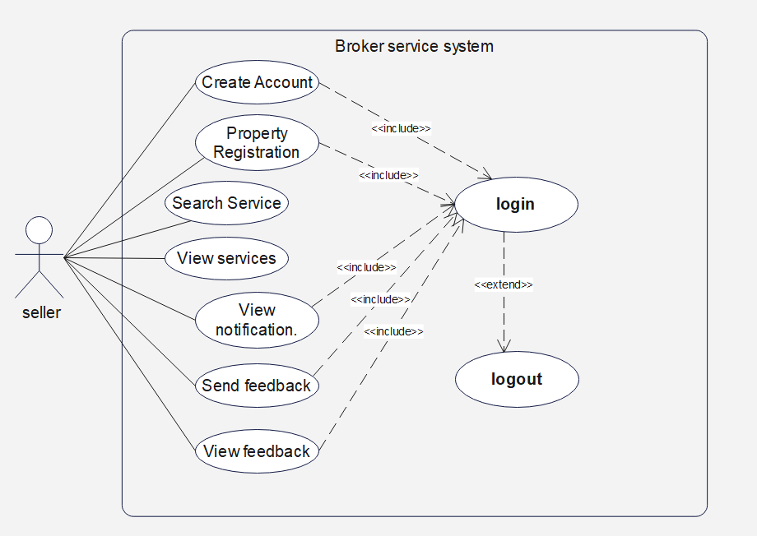

**4.4. Class Diagram**

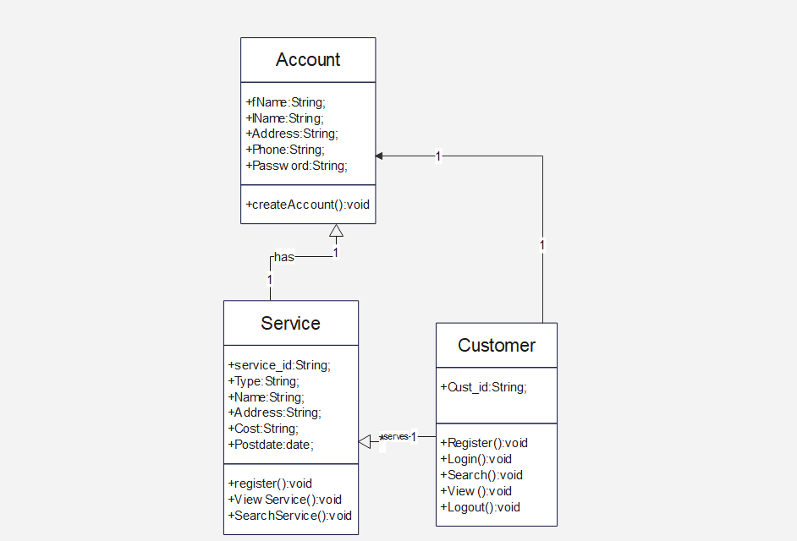

**4.6 Database design**

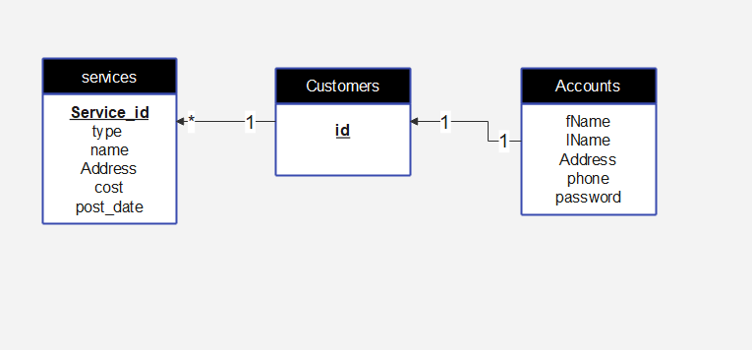

**4.7. User Interface mock-up**

